Capstone Explanation -2

* Import all five tables from the Excel File called “Section Six Data Extract” into Power Query Mode

Using POWER BI Desktop Application the “Section Six Data Extract” will be loaded into the database of POWER BI.

Steps to upload a file into POWER BI :-

1.Select Home in the Menu Bar .

2.From the ribbons click on Get Data and select the desired file type with extension.

3.Click and select all the check boxes to select all the 6 .xlsx files .

4. After selection of all the 6 .xlsx files either directly load the files into the database or transform and make specific changes or arrangements to the data for data cleansing.  
5.Once the Data Transformation is completed then press on “Close and Apply”.

* Create “Username” column inside dim_Customer table from the email address column. We are only looking for the text before the “@” symbol. The column should also be labelled “Username”.

To create a “username” column from the column “email address” that is already present in the dim_Customers table we need to follow certain steps and they are :-

1.Go to Transform data ribbon in the home tab menu.

2.After the window opens, go to insert tab and select custom column .

3.Give name accordingly to column and type the code to fetch the desired output.

Code :- Text.BeforeDelimiter(‘dim_Customers’[email],”@”)

* Scan the dim_Customer table and look out for columns with lots of Null values and remove them from the table.

To cleanse the data in the dim_customer there are certain steps to follow :-

1.In the Home Menu tab select the Transform data .

2.Step by step Click on the Drop Down list on every column .

3.Click on Remove Error on every column to remove the null values.  
4.Or if the whole column or almost 90% of values in the column consists of null values then remove the whole column.

* Import the tables into the model and check the connections between tables, make sure that every table is connected

To make connections between all the six tables present in the database :-

1.Go to Model View.

2.Check for data tables and lookup tables and analyze the columns in every table.

3.Make connections by connecting the columns from data table to lookup table.

4.Thus creating a Primary Key and Foreign Key relation to help the data flow from one table to the other.

5.Check for the cardinality required between 1-1,1-*,*-1, *-*.

6.Check for Filter of the data flow between 1 way or both way.

* Create dim_Date table using “fact_InternetSales[ShipDate]” column and create the following columns “Year”, “Month”, “Month Name”, “Day of Week”, “Quarter”, “Year/Quarter”. Make sure that the Month column is sorted correctly

Creating Table Date using fact_InternetSales from using the data value in the fact table :-

1.Duplicate the table fact_InternetSales .

2.Select the only column “date” from the new duplicated table select “Show only selected column”

3.From the date column in the new table dim_Date select the Date Ribbon and select certain option to make new column 1 by 1.

1. Year
2. Month
3. Month Name
4. Day of Week
5. Quarter of the year

* Dynamic measure for selected currency, based on the selected currency the measure should return the sales amount in the selected currency if no currency has been selected the measure should say “No currency selected”.

To create a Sales by Currency Measure we need to create a measure and then add a currency slicer to find the sales by currency  
  
We create a measure in the fact_InternetSales Data table  
  
Sales By Currency =

VAR SelectedCurrency = SELECTEDVALUE(dim_Currency[CurrencyKey])

RETURN

IF (SelectedCurrency = BLANK(), "No currency selected", SUMX(fact_InternetSales, [SalesAmount]))  
  
After completing this , when we use the slicer to filter the currency , it will show country wise Sales.

* Dynamic measure for a title that should say “Sales Amount in [Selected Currency] vs All Currencies“, alternatively it should say “Please Select Currency from the Dropdown Menu”

To create a Sales by Currency vs All countries Title Measure we need to create a measure and then add a currency slicer to find the sales by currency vs all the other countries.  
  
  
VS Currency =

VAR SelectedCurrency = SELECTEDVALUE(dim_Currency[CurrencyKey])

VAR SelectedCountryName = SELECTEDVALUE(dim_Currency[CurrencyName])

VAR SalesinOtherCountries = CALCULATE(SUMX(fact_InternetSales,fact_InternetSales[SalesAmount]),SelectedCurrency <> fact_InternetSales[CurrencyKey])

RETURN

IF

(SelectedCurrency = BLANK(), "Please Select Currency from the Dropdown Menu", "Sales Amount in " & SelectedCountryName & " is " & CALCULATE(SUMX(fact_InternetSales,fact_InternetSales[SalesAmount]),SelectedCurrency = fact_InternetSales[CurrencyKey]) & " VS Sales in Other Countries" & SalesinOtherCountries

)  
  
  
After completing this measure , when we use the slicer to filter the currency , it will show country wise Sales and be used as a title to show the country Sales Vs the other country sales.

* Create measures for Previous One Month, Previous Three Months and Previous Six Months

To create the measure for Sales for 30,60 and 90 days ,we create separate measures for them  
  
30 day Sales Measure  
  
  
30-Day Revenue = CALCULATE(SUM(fact_InternetSales[SalesAmount]),DATEADD(fact_InternetSales[ShipDate].[Date],-30,DAY))  
  
60 day sales measure  
  
60-Day Revenue = CALCULATE(SUM(fact_InternetSales[SalesAmount]),DATEADD(fact_InternetSales[ShipDate].[Date],-60,DAY))  
  
  
90 day sales measure  
  
90-Day Revenue = CALCULATE(SUM(fact_InternetSales[SalesAmount]),DATEADD(fact_InternetSales[ShipDate].[Date],-90,DAY))

* A measure that will tell us the time the report was last opened, the text should say “Executed: Date and Time”

This measure will show when the report was last opened and will keep or track of date and time and will only change if refresh is clicked  
  
Time Opened = "Executed: " & NOW()

* Create buttons for “Clear Filters” (apply red outline on this button only), “Users” (apply outline using color #e8d400 on the rest of the buttons), “Currency”, “Sales Territory”. Buttons need to be positioned inside the header

Creating 4 buttons in total by following certain set of steps  
  
Go to insert Menu Tab  
Select the Button Ribbon  
Drag the button according to the required position  
From the Format Tab select the button Shape   
Give a Title and content to your button  
Give an outline of Color Hex code of #e8d400 to all the button  
  
Create 4 buttons named Clear Filter, Users,Currency,Territory  
and give Clear filters a red outline and the other with the hex code provided.

* Create a bookmark that clears all the filters and apply it to “Clear Filters” button

Creating Bookmark for clear filters by deselecting everything and making a bookmark after all the Data is in Default State  
  
To create a book we need to follow certain steps  
  
Go to Insert Menu Tab  
Select Bookmark  
Give Clear Filters name to the bookmark  
Set data to default  
Right Click on Bookmark Clear Filters and Update   
  
Go to clear filters Button   
Go to Actions  
Give Action as bookmark Clear Filters   
Test the button if its working properly or not

* Create three boxes – first one to show Sales Amount in Selected Currency, a second one to show Sales Amount for All Currencies in Previous Month, Sales Amount for All Time for All Currencies. Each box should have the same outline color of #e8d400. The text should be aligned in the middle, font size to be increased based on user preference. Sales Amount for Last Month and Sales Amount for All Time should not be filtered when choosing currency or region from the Header menu.

For this we need to create 3 measures and 3 cards to visualize   
  
Creating all 3 measures 1 by 1  
  
**Measure 1 :- 30 days revenue**  
  
30-Day Revenue = CALCULATE(SUM(fact_InternetSales[SalesAmount]),DATEADD(fact_InternetSales[ShipDate].[Date],-30,DAY))  
  
**Measure 2 :- Sales By Currency**  
  
 Sales By Currency =

VAR SelectedCurrency = SELECTEDVALUE(dim_Currency[CurrencyKey])

RETURN

IF (SelectedCurrency = BLANK(), "No currency selected", SUMX(fact_InternetSales, [SalesAmount]))  
  
**Measure 3 :- Sales VS Country**  
  
VS Currency =

VAR SelectedCurrency = SELECTEDVALUE(dim_Currency[CurrencyKey])

VAR SelectedCountryName = SELECTEDVALUE(dim_Currency[CurrencyName])

VAR SalesinOtherCountries = CALCULATE(SUMX(fact_InternetSales,fact_InternetSales[SalesAmount]),SelectedCurrency <> fact_InternetSales[CurrencyKey])

RETURN

IF

(SelectedCurrency = BLANK(), "Please Select Currency from the Dropdown Menu", "Sales Amount in " & SelectedCountryName & " is " & CALCULATE(SUMX(fact_InternetSales,fact_InternetSales[SalesAmount]),SelectedCurrency = fact_InternetSales[CurrencyKey]) & " VS Sales in Other Countries" & SalesinOtherCountries

)  
  
  
Giving all 3 the outline of the hex code provided above.

* Using Line and stacked column chart create a visual that shows all Sales Amount in All Currencies, split by month name. Bar color to be #293537. Font size to be increased accordingly. **\*Inside the chart we should show the selected currency from the dropdown menu as a dot. Marker size to be 10 pixels.**The dot color should be #e8d400. The chart should also have a Legend. Legend to be positioned in Top Center. Data labels should be visible for the bars, but not for the dots. The visual should have a placeholder in the background with line color #e8d400

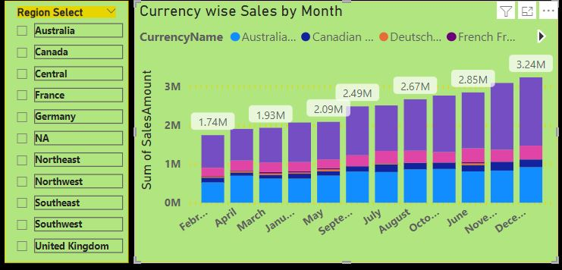

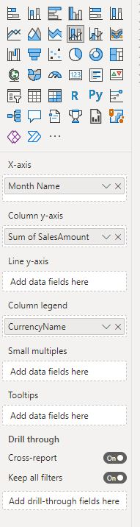

* Number of Products Sold by Country to be shown inside a map visual. Change the color of the country to #e8d400. The visual should have a placeholder in the background with line color #e8d400

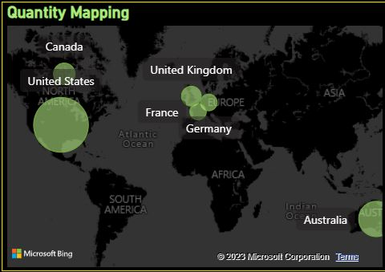

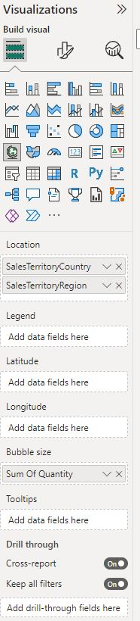

* Create a table that shows the SalesTerritory along with the Sales Amount as %, Total Sales Amount, Sales for Previous One Month, Previous Three Months, Previous Six Months. Font size to be increased accordingly, outline to be removed. Column headers to be colored in #e8d400. Totals should have the same background color as per headers. Remove the outline from Totals as well. SalesTerritoryCountry background color to be changed to the same color as Totals. All headers should be capitalised. Apply conditional formatting to the Total Sales Amount %. If values are between 0 and less than or equal to 0.2 make it red, if it is greater than or equal to 0.2 and less than 0.5, make it #e8d400, if it is greater than or equal to 0.5 and less than or equal to 1, make it green

We need to create a matrix and add the following measures to get the desired output

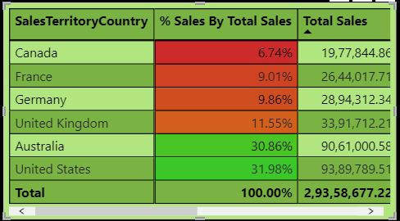

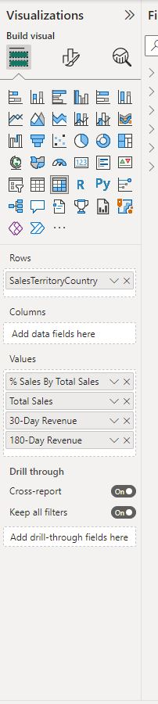

Measures used in this matrix are   
  
% Sales by Total Sales  
Total Sales  
30 day revenue  
180 day revenue